Logic Microoperations
Logic microoperations specify binary operations for strings of bits stored in registers. These operations consider each bit of the register separately and treat them as binary variables.
For example, the exclusive-OR microoperation with the contents of two registers R1 and R2 is symbolized by the statement
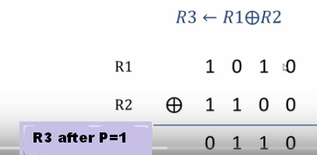
It specifies a logic microoperation to be executed on the individual bits of the registers provided that the control variable P=1.
List of logic microoperations
There are 16 different logic operations that can be performed with two binary variables.
(For example, when n = 2 (two variables), there are 2² = 4 possible combinations of Boolean values for those two variables:
(True,True), (True,False), (False,True), and (False,False). We call these combinations "cases."
There are 2⁴ = 16 different Boolean functions of two variables covering the above four cases.) No need to write the content with in () here. Only for explanation.
In this table, each of the 16 columns F₀ through F₁₅ represents a truth table of one possible Boolean function for the two variables x and y.

Functions are determined from the 16 binary combinations that can be assigned to F. The 16 logic microoperations are derived from these functions by replacing variable x by the binary content of register A and variable y by binary content of register B.
Boolean functions in the first column of Table 4-6 represent a relationship between two binary variables x and y.
The logic microoperations listed in the second column represent a relationship between the binary content of two registers A and B. Each bit of the register is treated as a binary variable and the microoperation is performed on the string of bits stored in the registers.

